2017

UK CANSAT COMPETITION

Guidelines

**Table of contents**

1 INTRODUCTION 3

2 COMPETITION OVERVIEW 4

2.1 Call for proposals and team selection 4

2.2 Teachers’ introductory workshop 5

2.3 CanSat construction and test activities 5

2.4 Competition launch campaign and prize event 6

2.5 Timeline 7

3 Cansat equipment 8

3.1 The rocket launch 8

3.2 Primary and secondary CanSat missions 8

3.2.1 Primary mission 8

3.2.2 Secondary Mission 8

3.3 CanSat Requirements 9

4 evaluation and scoring 11

4.1 Educational value 11

4.2 Technical achievement 11

4.3 Teamwork 11

4.4 Outreach 11

4.5 Marking scheme 11

5 Finance 12

6 CONTACT and Further Reference 12

# INTRODUCTION

ESA wishes to foster and support a broad range of CanSat activities across its Member States, in order to give European high school students their first experience of a real space-related project. ESA has organised six previous European CanSat Competitions in 2010, 2012, 2014, 2015 and 2016.

The UK branch of the European Space Education Resources Office (ESERO-UK) organises the UK CanSat Competition. The winner of the UK competition may go on to compete in the European CanSat Competition.

A CanSat is a simulation of a real satellite, integrated within the volume and shape of a soft drink can. The challenge for the students is to fit all the major subsystems found in a satellite, such as power, sensors and a communication system, into this minimal volume. The CanSat is then launched to an altitude of a few hundred metres by a rocket or dropped from a drone or captive balloon and its mission begins: to carry out a scientific experiment and achieve a safe landing.

CanSats offer a unique opportunity for students to have a first practical experience of a real space project. They are responsible for all aspects: selecting the mission objectives, designing the CanSat, integrating the components, testing, preparing for launch and then analysing the data.

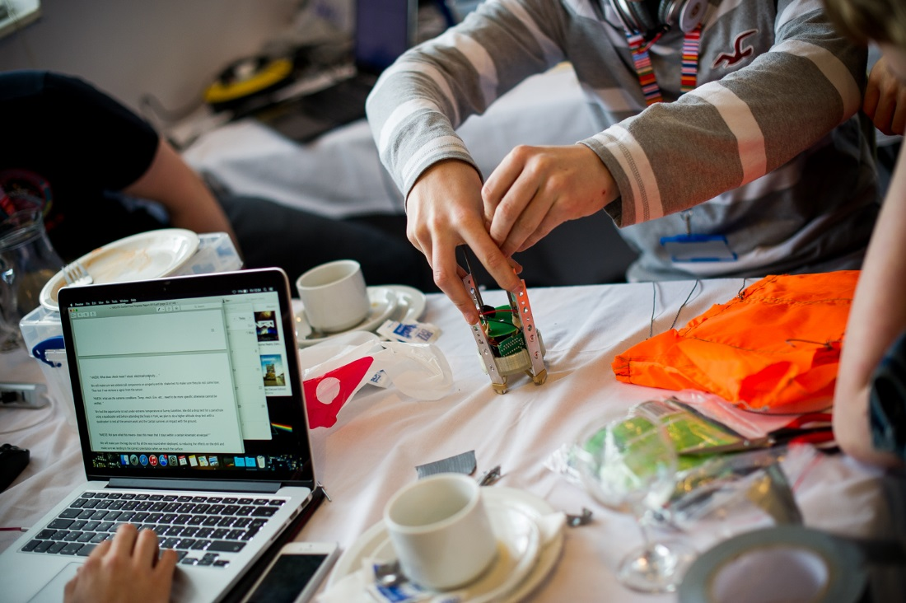

Fig. 1: UK CanSat Competition 2015

# COMPETITION OVERVIEW

The UK CanSat Competition will consist of four phases:

1. Call for proposals and team selection
2. Teachers’ introductory workshop
3. CanSat construction and test activities
4. Competition launch campaign

## Call for proposals and team selection

An announcement of opportunity is published on the ESERO-UK website [www.stem.org.uk/esero](http://www.stem.org.uk/esero) and on the CanSats in Europe website [www.cansat.eu](http://www.cansat.eu) , with information about the competition and guidelines for applications.

Proposals are reviewed against certain selection criteria and a number of teams are selected for the UK competition.

**Eligibility**

* The team should comprise between 4 and 10 students, assisted by a teacher or tutor. At least 4 of these students must be over 14 years of age at the time of the launch campaign.
* The team members must be enrolled as full-time students
* The majority of team members must hold UK citizenship
* A completed application must be submitted to ESERO-UK by July 2016

**Responsibility for leading the team**

Each team should have a teacher or a tutor responsible for monitoring the team’s technical progress, available to offer help and advice, and acting as the point-of-contact between the organisers and the student team. The teacher/tutor must be available to attend some training like “The teachers’ introductory workshop” and to accompany the team to the competition launch campaign.

It is recommended that the team have a mentor within a university or industry to assist in their project, should they be selected. ESERO-UK can help teams to find a mentor.

## Teachers’ introductory workshop

Before the students start work on their projects, a workshop will be held for the teachers of each team to introduce the CanSat concept, demonstrate how the hardware and software works and give teachers the opportunity to build their own CanSat. This workshop will take one or two days and will be held in September.

## CanSat construction and test activities

Students are encouraged to follow a normal space project lifecycle as follows:

* Selection of mission objectives
* Definition of requirements
* Design of hardware and software
* One or more reviews of the design (leading to design refinement)
* Integration and testing
* Launch and operations
* Data analysis and reporting of results

Guidelines for the activities, as well as templates for the required reports, will be provided to each team that is selected to participate in the competition. Expert advice should be made available throughout this phase: questions can be posted on an open forum, so that information is available to all teams.

## Competition launch campaign and prize event

The highlight of the competition will be the competition launch campaign, where each CanSat will be launched.

The site for the launch event will depend upon the chosen launch platform. The most common options are:

* A drone, dropping from 120m
* A captive (tethered) balloon, dropping from ~150m

Rocket launches are subject to strict legal and safety requirements, which should be investigated well in advance.

A typical programme for a launch event is as follows:

Day 1

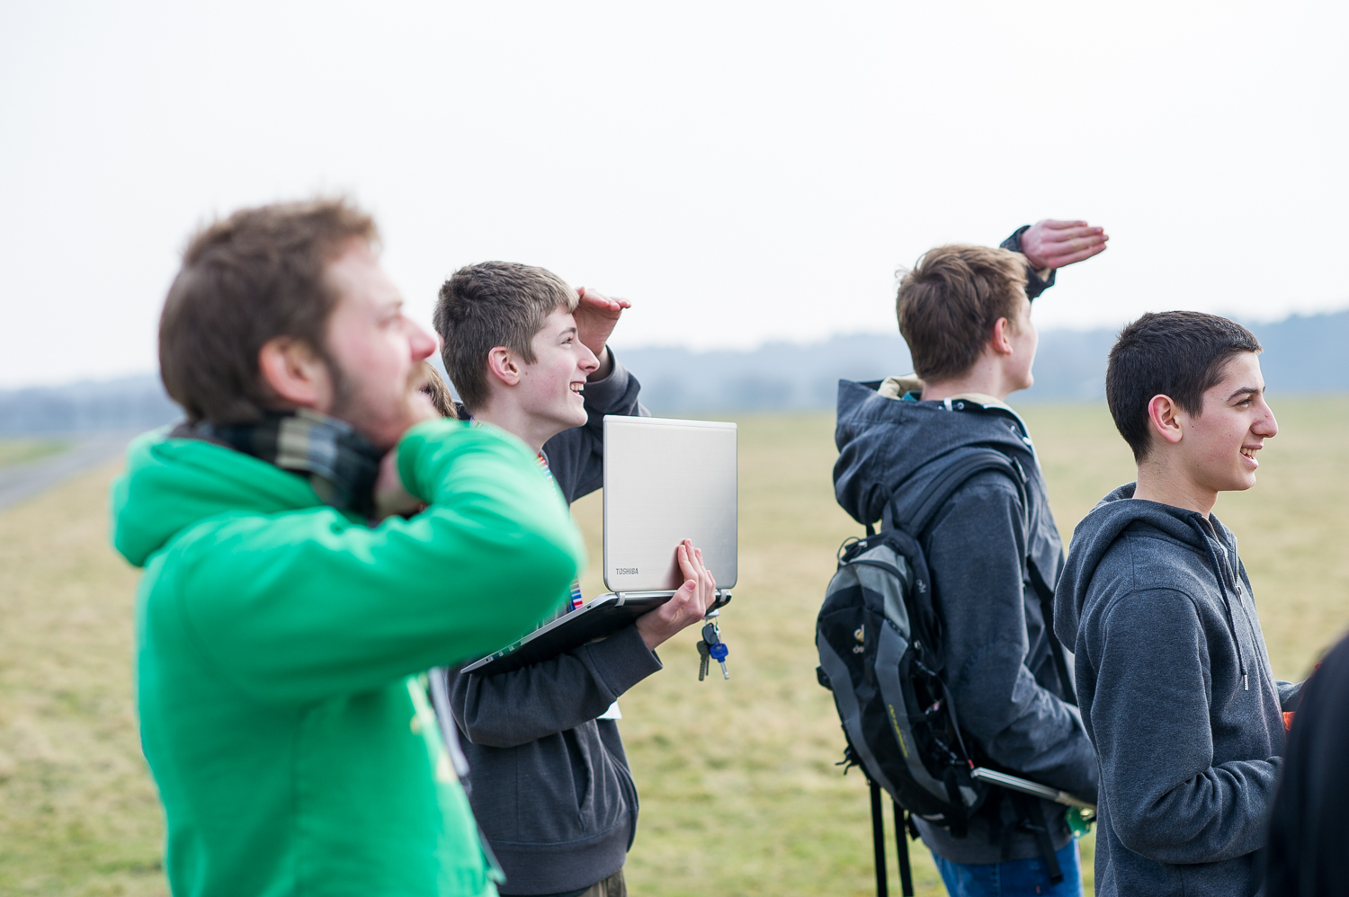

*Fig. 2: Students track their CanSat*

*during its descent*

* Final integration and technical

Inspection of the CanSats

Day 2

* Launch and recovery operations
* Analysis of the mission data and

conclusion of results

Day 3 (sometimes several days later)

* Student teams present data analysis

and results to the jury

* Competition prize ceremony

A report on the results from the launch is required from each team. The competition winners will then be chosen based on the team’s performance throughout the project, as well as the final flight operations and results.

## Timeline

|  |  |
| --- | --- |
| **Phase 1: Call for proposals and team selection** | |
| **Activity** | **Deadline** |
| Call for proposals opens | May 2016 |
| Deadline for proposals | 8th July 2016 |
| Announcement of selected teams | 22nd July 2016 |
| **Phase 2: Teachers’ introductory workshop** | |
| **Activity** | **Deadline** |
| Teachers’ introductory workshop | 23rd September 2016 |
| **Phase 3: CanSat construction and test activities** | |
| **Activity** | **Deadline** |
| Progress report 1 | 31st October 2016 |
| Progress report 2 | 12th December 2016 |
| Progress report 3 (as-built documentation) | 28th February 2017 |

|  |  |
| --- | --- |
| **Phase 4: Competition launch campaign and post-flight activities** | |
| **Activity** | **Deadline** |
| Competition launch campaign and awards | TBD March 2017 |

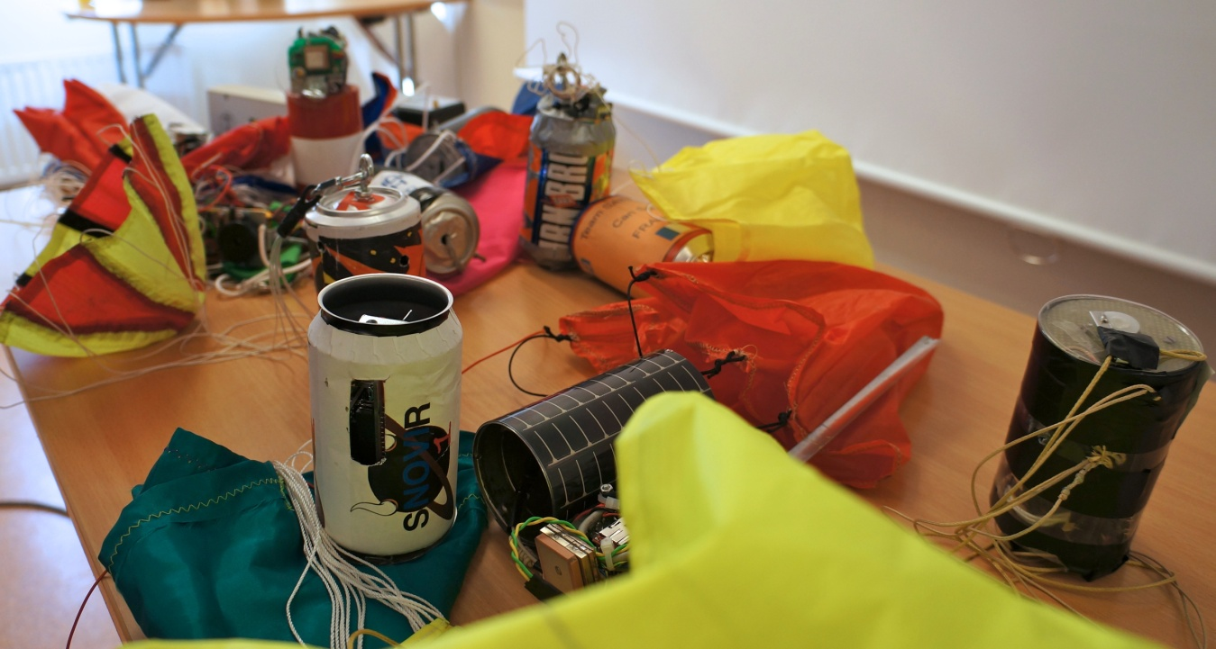

Fig. 3: A selection of CanSats from the 2012 European CanSat Competition

# Cansat equipment

Designing and building a CanSat from scratch is a daunting prospect for students with no prior experience of such an activity. For this reason, many teams start with a CanSat kit, which already contains the basic elements, and adapt it to their own requirements.

Additional hardware will need to be purchased to meet the requirements of the secondary mission (see below).

## The launch

The launch will be from a drone or from a tethered balloon. Requirements for launch are listed in section 3.3.

## Primary and secondary CanSat missions

### Primary mission

The team must build a CanSat and program it to accomplish the compulsory primary mission, as follows:

**After release and during descent, the CanSat shall measure the following parameters and transmit the data as telemetry once every second to the ground station:**

• **Air temperature**

• **Air pressure**

It must be possible for the team to analyse the data obtained (for example, make a calculation of altitude) and display it in graphs (for example, altitude vs. time and temperature vs. altitude).

### Secondary Mission

The secondary mission for the CanSat must be selected by the team. It can be based on other satellite missions, a perceived need for scientific data for a specific project, a technology demonstration for a student-designed component, or any other mission that would fit the CanSat’s capabilities.

Some examples of missions are listed below, but teams are free to design a mission of their choice, as long as it can be demonstrated to have some scientific, technological or innovative value. Teams should also keep in mind the limitations of the CanSat mission profile, and focus on the feasibility (both technical and administrative) of their chosen mission.

Some example secondary missions:

1. Advanced telemetry

After release and during descent, the CanSat measures and transmits additional telemetry to that required for the primary mission, for example:

• Acceleration

• GPS location

• Radiation levels

2. Telecommand

During descent, commands are sent from the ground to the CanSat to perform an action, such as switching a sensor on and off, changing the frequency of measurements, etc.

3. Targeted landing

The CanSat navigates autonomously with a control mechanism such as a parafoil. The objective is for the CanSat to land as close as possible to a fixed target point on the ground after it has been released from the rocket. This mission is an advanced telemetry/telecommand mission - navigation data is exchanged between the CanSat and a ground station throughout the descent.

4. Landing system

For this mission, an alternative safe landing system for the CanSat would be deployed, such as a bespoke parachute or airbag.

5. Planetary probe

The CanSat simulates an exploration flight to a new planet, taking measurements on the ground after landing. Teams should define their exploration mission and identify the parameters necessary to accomplish

## CanSat Requirements

The CanSat hardware and missions must be designed to the following requirements and constraints:

[1] All the components of the CanSat must fit inside a standard soda can (115 mm height and 66 mm diameter), with the exception of the parachute. An exemption can be made for radio antennas and GPS antennas, which can be mounted externally (on the top or bottom of the can, not on the sides), based on the design.

N.B. In the case of the T-Minus Engineering rockets, the space allocated for each CanSat is 66 mm diameter and a height of 200 mm. The extra height can ONLY be used for the exemptions mentioned.

[2] The antennas, transducers and other elements of the CanSat cannot extend beyond the can’s diameter until it has left the launch vehicle.

[3] The mass of the CanSat must be between 300 g and 350 g. CanSats that are lighter must take additional ballast with them to reach the 300 g mass limit required.

[4] Explosives, detonators, pyrotechnics, and flammable or dangerous materials are strictly forbidden. All materials used must be safe for the personnel, the equipment and the environment. Material Safety Data Sheets (MSDS) will be requested in case of doubt.

[5] The CanSat must be powered by a battery and/or solar panels. It must be possible for the systems to be switched on for three continuous hours.

[6] The battery must be easily accessible, in case it has to be replaced or recharged in the field.

[7] The CanSat must have an easily accessible master power switch.

[8] The CanSat should have a recovery system, such as a parachute, which is able to be reused after launch. It is recommended to use bright coloured fabric, which will facilitate recovery of the CanSat after landing.

[9] The parachute connection must be able to withstand up to 1000N of force. The strength of the parachute must be tested, to give confidence that the system will operate nominally.

[10] The decent time of the CanSat when falling from 120 metres **is limited to 20 seconds**. This is a requirement from the launch site since this will guarantee that the CanSat lands within the landing area under all wind conditions.

[11] The descent rate must be at least 10m/s.

[12] The CanSat must be able to withstand an acceleration of up to 2g for balloon launch or 20g for rocket launch.

[13] The recovery of the CanSat is not guaranteed after the launch.

[14] The total budget of the CanSat should not exceed £400. This does not include ground support equipment, such as laptops, power supplies, antennas.

# evaluation and scoring

The teams will be evaluated on an ongoing basis, with the following items being taken into account:

## Educational value

For this item, the jury will consider the quality of the progress reports and the team presentations, the level of effort made by the team and how much the team appear to have learned throughout the project.

## Technical achievement

Innovative aspects of the project will be judged, for example: the mission selected and the hardware/software used. It will be also taken into account how the teams obtained the results, how reliable and robust the CanSat was and how the CanSat performed. If the CanSat did not succeed in accomplishing the missions but the team is able to explain the reasons why and suggest improvements, it will be also taken into account positively.

## Teamwork

The jury will assess how well the team worked together on the assignment, the distribution of tasks, the planning and execution of the project and the team’s success in obtaining the necessary funding, support and advice.

## Outreach

The team will be scored on how well the project was communicated to the school and the local community, taking into account any webpages, blogs, presentations, promotional materials, media coverage, etc.

|  |  |  |  |  |  |  |  |  |  |  |
| --- | --- | --- | --- | --- | --- | --- | --- | --- | --- | --- |
| Marking scheme  |  |  | | --- | --- | | 1 Educational value | 20% | | 2 Technical achievement | 50% | | 3 Teamwork | 15% | | 4 Outreach | 15% | | **TOTAL** | **100%** | |

# Finance

This section outlines the expectations as to ownership of costs for the competition. This is for guidance only and does not constitute an agreement between ESERO-UK and any third party.

ESERO-UK will pay for

* Accommodation for one night at the teachers’ workshop
* Catering for the duration of the teachers’ workshop
* One basic T-Minus Cansat kit per team
* Accommodation and catering for the launch campaign for one teacher and up to four students
* Accommodation and catering for the final presentations and awards for one teacher and up to four students

The school or sponsors will pay for

* Transport to and from each event outlined above
* Any additional electronic equipment required for the secondary mission or ground support
* Costs associated with more than one teacher and four students from each team attending an event
* Any costs of cover for teaching
* Any other costs incurred by the team not specified above

# CONTACT and Further Reference

All questions and expressions of interest should be directed to:

**Tom Lyons**

ESERO-UK

National STEM Centre

University of York

York

YO10 5DD

Tel: +44 1904 328178

Email: [t.lyons@stem.org.uk](mailto:t.lyons@stem.org.uk)

Website: [www.stem.org.uk/esero/cansat](http://www.stem.org.uk/esero/cansat)

**Further Reference**

* CanSats in Europe Portal <http://www.cansat.eu>

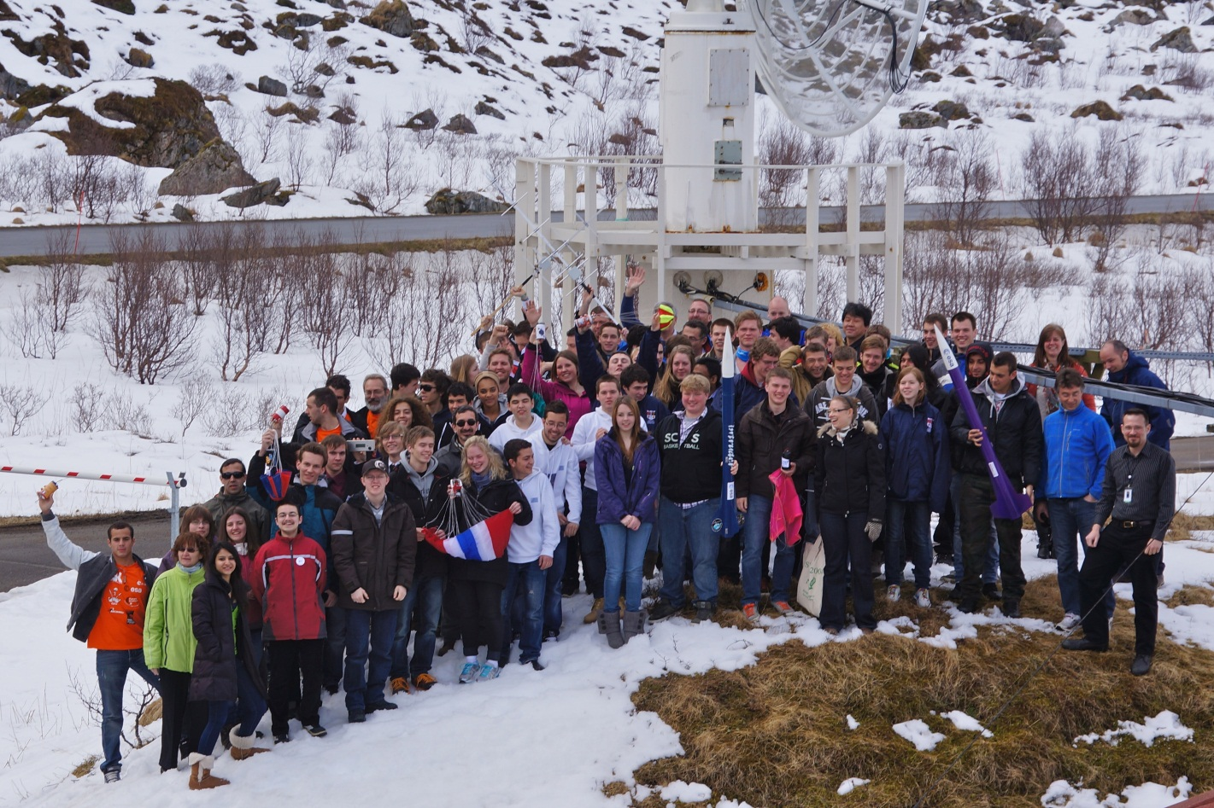

*Fig. 5: Participants of the 2012 European CanSat Competition, 22-26 April 2012,*

*at Andøya Rocket Range, Norway*